**Uniform distr case**

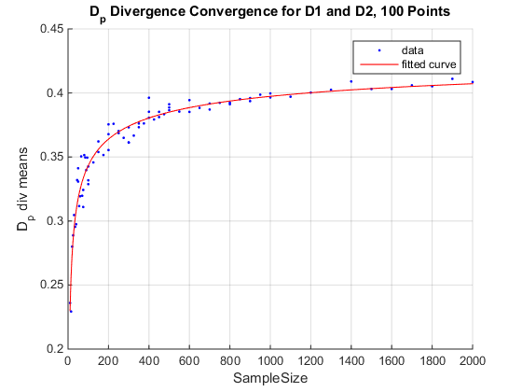

2000 point (uniform distr case)

**Gaussian Case**

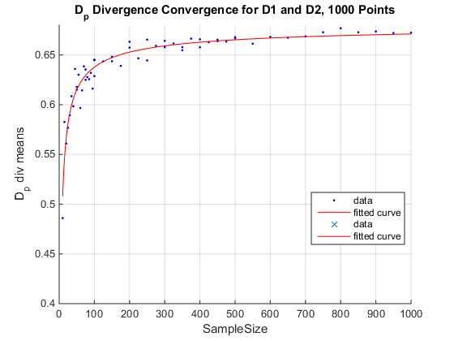

b = -0.5897 (-0.7127, -0.4667)

c = 0.6827 (0.6719, 0.6935)1000 points

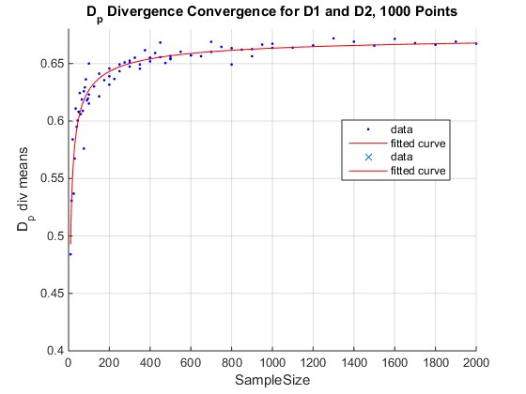

b = -0.5634 (-0.6612, -0.4656)

c = 0.6771 (0.6685, 0.6857)

2000